**DBMS LAB-04(09-01-2025)**

**Name-** Bhavya Shrivastava **Roll No-** 23052071 **Section-** CSE-15

**Q1: Display the current date.**

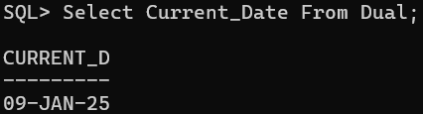

**Q2: Display employees' names, DOJ, and their permanent date.**

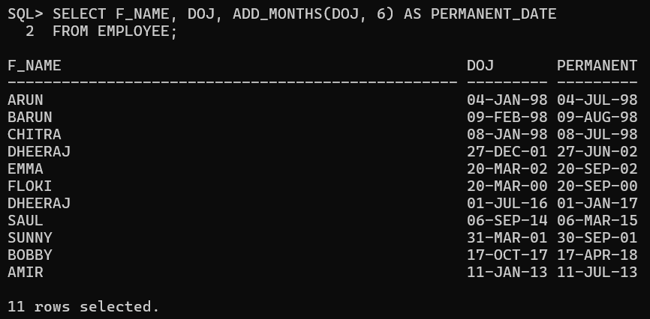

**Q3: Display the last date of this current month.**

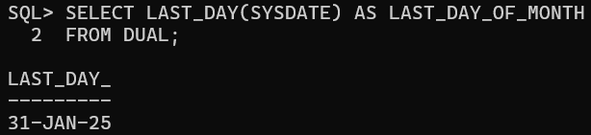

**Q4: Display emp_id, f_name, and total experience in months.**

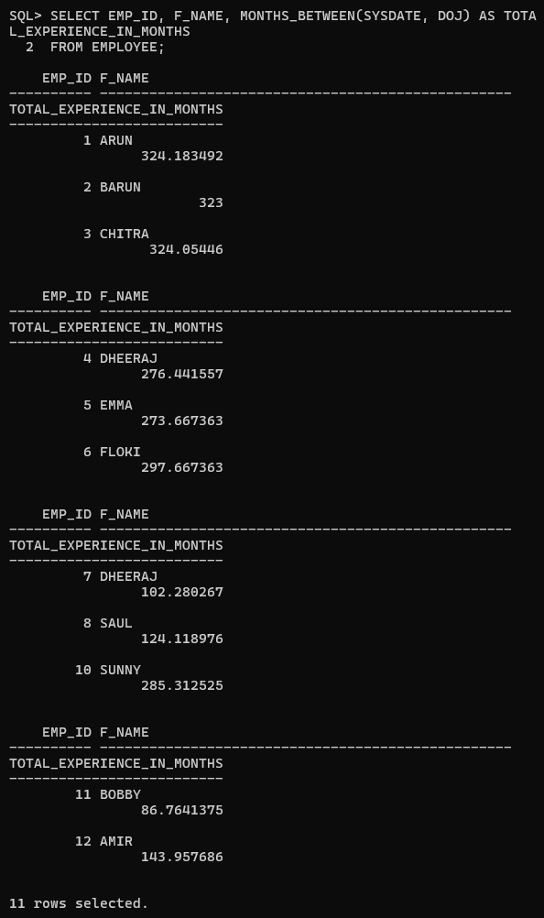

**5. WAQ to display the date of next TUESDAY.**

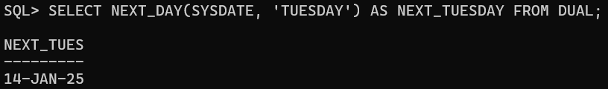

**6. WAQ to extract the current month.**

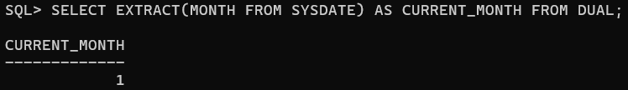**7. WAQ to extract the current year.**

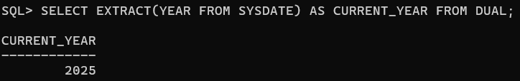

**8. WAQ to display the absolute value of -505.**

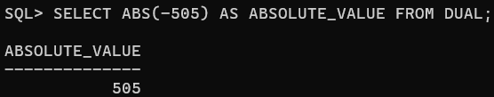

**9. WAQ to display the ceiling of 10.44, 10.50, and 10.65.**

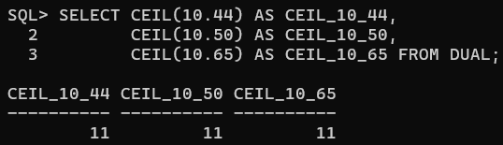

**10. WAQ to display the floor value of 10.44, 10.50, and 10.65.**

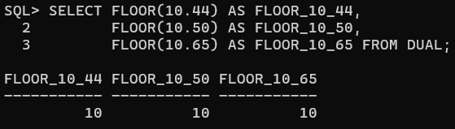

**11. Find the logarithmic value of 10 base 2.**

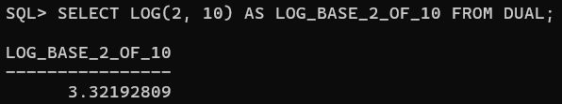

**12. Display the remainder in 594/7.**

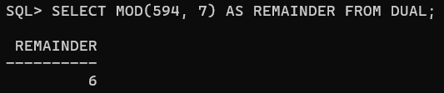

**13. WAQ to display the value of 8 to the power 3.**

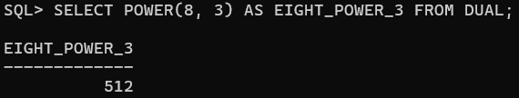**14. WAQ to display the square root of 3481.**

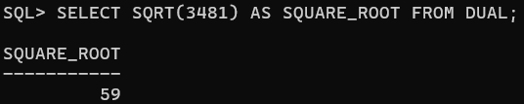

**15. Display the following rounding operations.**

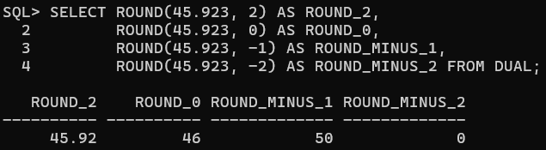

**16. Display the following truncation operations.**

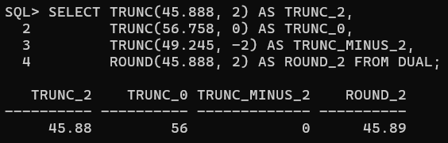

**17. WAQ to return the sign of 20, -67.60, and 0.**

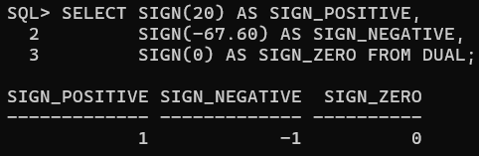

**18. Display the value of cos(45), sin(45), and tan(45).**

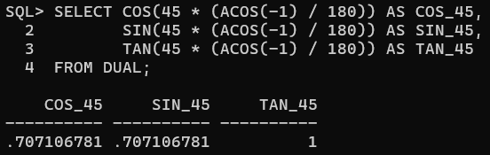

**19. Display the ASCII character corresponding to the integer 79.**

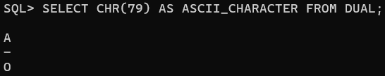

**20. Display the f_name and l_name together using the concat() function.**

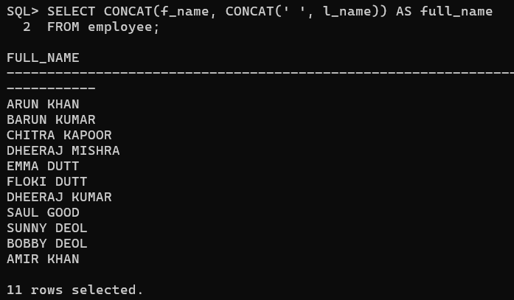

**21. Display all the f_names in capital letters.**

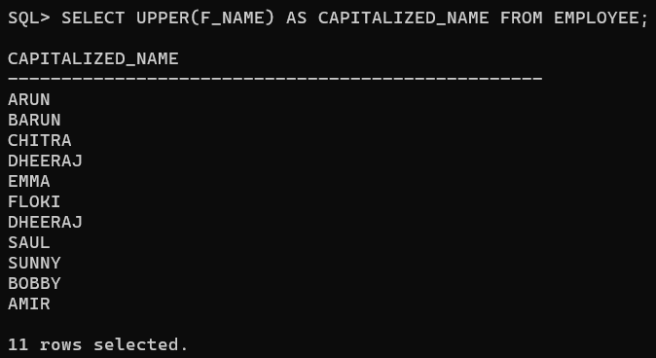

**22. Find the length of the first name and last name of all employees who work in the sales department.**

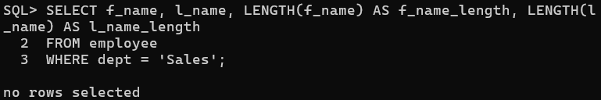

1. **Determine the tax-rate for each employee based on their monthly salary.**

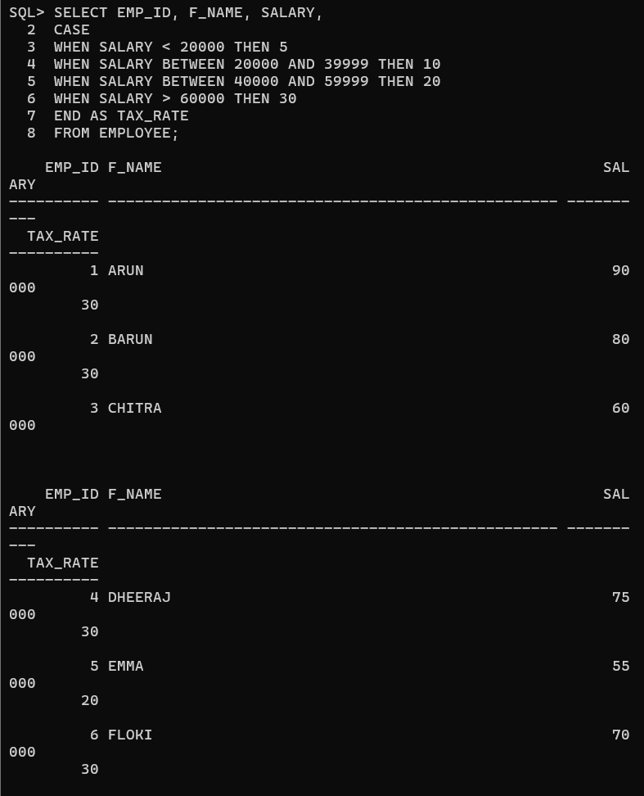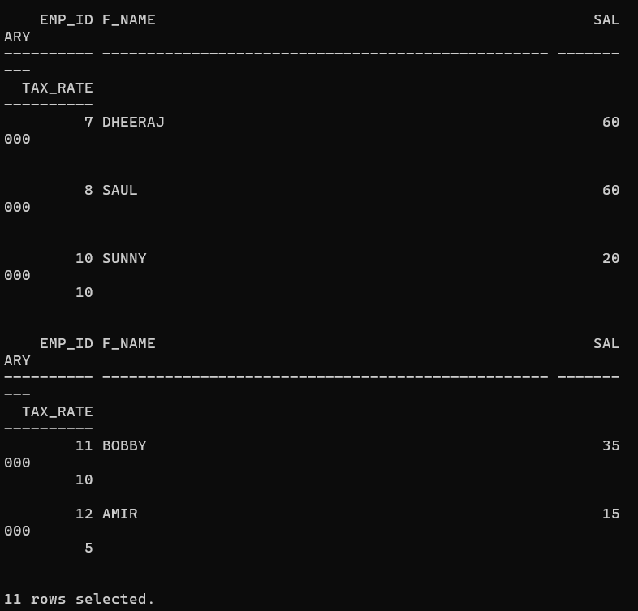

**24. Find the average salary, maximum salary, minimum salary, and the sum of salaries from the employee table.**

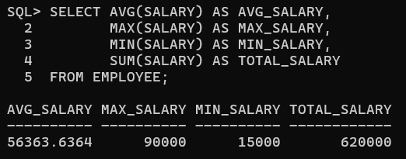

**25. Find the average salary, maximum salary, minimum salary, and the sum of salaries of employees who work for the sales department.**

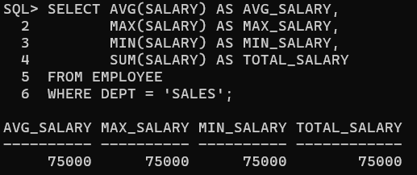

**26. Find the newest and oldest employee.**

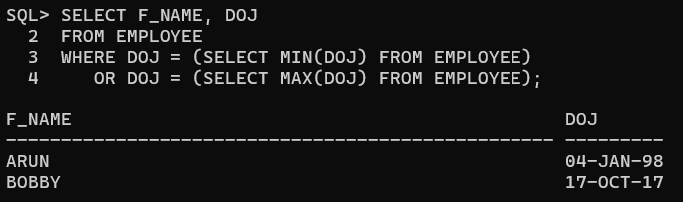

**27. Find those two employees whose l_name comes first and last in alphabetical order.**

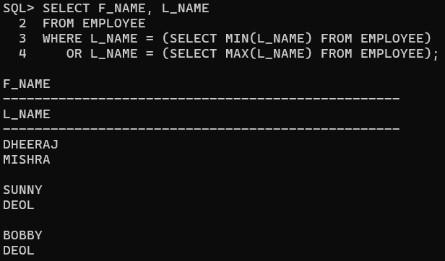

**28. Find the number of engineers.**

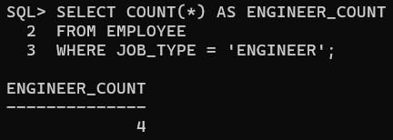

**29. Find the number of departments from the employee table.**

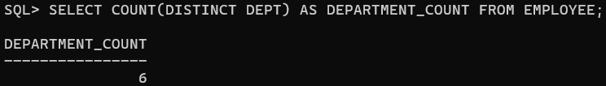

**30. Find the average commission from the employee table.**

